List
List are ordered and mutable
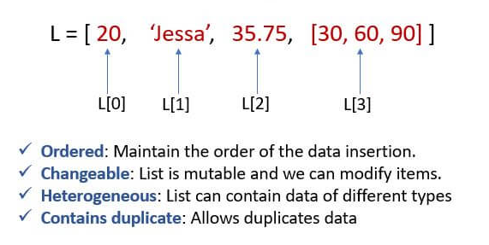
Feature | List | Array
Data types | Can store elements of different data types | Can only store elements of the same data type
Size | Can be resized as needed | Fixed size

List creation
mylist=[10,20,30,40,50]
print(mylist)#[10, 20, 30, 40, 50]
mylist=["apple", "orange", "cherry"]
print(mylist)#['apple', 'orange', 'cherry']
mylist=[10,20, 30, 40, 50, "apple", "orange", "cherry"]
print(mylist)#[10, 20, 30, 40, 50, 'apple', 'orange', 'cherry']
mylist=list(["apple", "orange", "cherry"])
print(mylist)#['apple', 'orange', 'cherry']

empty list

mylist = list()
print(mylist)
(or)
mylist = []
print(mylist)

Accessing list elements
List elements can be accessed using index

mylist=["apple", "orange", "cherry", "banana"]
print(mylist[0])#apple
print(mylist[-2])#cherry
# print(mylist[4]) # index error for non exisiting index
print(mylist[3:4])#['banana']
print(mylist[::-1])#['banana', 'cherry', 'orange', 'apple']

Change elements using index
mylist=["apple", "orange", "cherry", "banana"]
mylist[1] = "grape"
print(mylist)

For loop with list

mylist=["apple", "orange", "cherry", "banana"]
for i in mylist:
print(i)

output:
apple
orange
cherry
banana

for i in mylist[1:3]:
print(i)

output:
orange
cherry
for i in mylist[::-1]:
print(i)

output:
banana
cherry
orange
apple

Check the existence of element

mylist=["apple", "orange", "cherry", "banana"]
print("banana" in mylist)# True
print("bananadcec" in mylist)#False

Get Length of list
mylist=["apple", "orange", "cherry", "banana"]
print(len(mylist))#4

Add element in list
mylist=["apple", "orange", "cherry", "banana"]
# using append()
mylist.append("kiwi")
print(mylist)# ['apple', 'orange', 'cherry', 'banana', 'kiwi']
# using insert()
mylist.insert(2,"Dragon frt")
print(mylist)# ['apple', 'orange', 'Dragon frt', 'cherry', 'banana', 'kiwi']

Removing element from list
mylist=["apple", "orange", "cherry", "banana"]
#using pop
mylist.pop() # element present at the last will get removed # ['apple', 'orange', 'cherry']
mylist.pop(1) # element present at the index will get removed # ['apple', 'cherry']
print(mylist)
#using del
del mylist[2]
print(mylist)# ['apple', 'orange', 'banana']
del mylist # deletes variable
# print(mylist) # nameerror
# appr3
mylist.remove("kiwi")
print(mylist)

# using clear
mylist.clear()
#mylist.clear(1) #TypeError: list.clear() takes no arguments (1 given)
print(mylist) # return empty list # []

Copying list
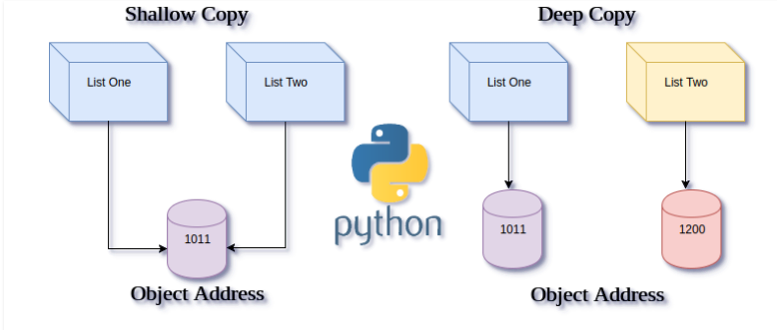

mylist1=["apple", "orange", "cherry", "banana"]
print(f"id mylist1 {id(mylist1)}")#id mylist1 1508372804544
print(f"id mylist2 {id(mylist2)}")# id mylist1 1508372804544
mylist2 = mylist1
print(mylist2) # swallow copy #['apple', 'orange', 'cherry', 'banana']
mylist2.remove("apple")
print(mylist1)#['orange', 'cherry', 'banana']
print(mylist2)#['orange', 'cherry', 'banana']
Note: in shallow copy, any element removed from list1 will remove element in list2 because both list1 and list2 refers same object
mylist3 = list(mylist1) ## deep copy
print(mylist3)
print(f"id mylist3 {id(mylist3)}")# id mylist3 2803296206784

mylist1.remove("apple")
print(mylist1)#['orange', 'cherry', 'banana']
print(mylist3)#['apple', 'orange', 'cherry', 'banana']

Note: in deep copy, any element removed from list1 will not remove element in list3 because both list1 and list3 refers different object

mylist4 = mylist1.copy() # deep copy
print(mylist4)#['apple', 'orange', 'cherry', 'banana']
print(f"id mylist4 {id(mylist4)}")#id mylist4 2196163818048
mylist4.remove("apple")
print(mylist1)#['apple', 'orange', 'cherry', 'banana']
print(mylist4)#['orange', 'cherry', 'banana']

Combine two lists

list1=[10,20, 30, 40, 50]
list2=["apple", "orange", "cherry"]
# appr 1
print(list1+list2)[10, 20, 30, 40, 50, 'apple', 'orange', 'cherry']
# appr2
for i in list2:
list1.append(i)
print(list1) #[10, 20, 30, 40, 50, 'apple', 'orange', 'cherry']
for i in list1:
list2.append(i)
print(list2)#['apple', 'orange', 'cherry', 10, 20, 30, 40, 50]
# appr3
list1.extend(list2)
print(list1)#[10, 20, 30, 40, 50, 'apple', 'orange', 'cherry']

Comparator operator
list1=[10,20, 30, 40, 50]
list2=["apple", "orange", "cherry"]
print(list1!=list2)# True
print(list1==list2)# False

Convert list to string
The join() method takes all items in an iterable and joins them into one string.
list1=['apple', 'orange', 'grape']
print("".join(list1))# appleorangegrape
print(",".join(list1))# apple,orange,grape
print(" and ".join(list1))# apple and orange and grape

Convert string to list
The split() method splits a string into a list.
str1="apple,orange,grape"
list1=str1.split(",") # list
print(list1)#['apple', 'orange', 'grape']
str1="welcome to python"
print(str1.split()) # splitting based on space#['welcome', 'to', 'python']
print(str1.split("to")) # splittting based on "to"#['welcome ', ' python']

Tuples
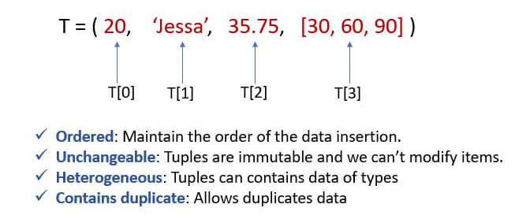
Tuples are ordered collections of heterogeneous data that are unchangeable.
When to use tuples?
As tuples and lists are similar data structures, and they both allow sequential data storage, tuples are often referred to as immutable lists. So the tuples are used for the following requirements instead of lists.
- There are no append() or extend() to add items and similarly no remove() or pop() methods to remove items. This ensures that the data is write-protected. As the tuples are Unchangeable, they can be used to represent read-only or fixed data that does not change.

Create Tuple
mytuple=(10,20,30,40,50)
print(mytuple)#(10, 20, 30, 40, 50)
mytuple=("apple", "orange", "cherry")
print(mytuple)#('apple', 'orange', 'cherry')
mytuple=(10,20,30,40,50, "apple", "orange", "cherry")
print(mytuple)#(10, 20, 30, 40, 50, 'apple', 'orange', 'cherry')
mytuple=tuple((10,20,30,40,50, "apple", "orange", "cherry"))
print(mytuple)#(10, 20, 30, 40, 50, 'apple', 'orange', 'cherry')

Empty Tuple
Approach 1
mytuple = tuple()
print(mytuple)

Approach 2
mytuple = ()
print(mytuple)

Accessing elements

mytuple=("apple", "orange", "cherry")
print(mytuple[0])#apple
print(mytuple[-1])#cherry
print(mytuple[1:3])#('orange', 'cherry')
print(mytuple[::-1])#('cherry', 'orange', 'apple')

Tuples with for loop
mytuple=("apple", "orange", "cherry", "kiwi")
for i in mytuple:
print(i)

output:
apple
orange
cherry
kiwi
for i in mytuple[::-1]:
print(i)

output:
kiwi
cherry
orange
apple

Change element in tuple
mytuple=("apple", "orange", "cherry", "kiwi")
mytuple[0] = "grape"
print(mytuple) # TypeError: 'tuple' object does not support item assignment
Note: Tuples are immutable so cannot change a element in tuple but there is indirect way to achieve that.
mytuple=("apple", "orange", "cherry", "kiwi")
# 1.convert tuple to list using list()
# 2.change the element
# 3.convert from list to tuple
mylist = list(mytuple) # tuple to list
mylist[0]="grape"
print(mylist)#['grape', 'orange', 'cherry', 'kiwi']
mytuple=tuple(mylist) # list to tuple
print(mytuple)#('grape', 'orange', 'cherry', 'kiwi')

Existence of element in tuple
mytuple=("apple", "orange", "cherry", "kiwi")
print("apple" in mytuple)#True
print("appledffv" in mytuple)#False

Get length of tuple
mytuple=("apple", "orange", "cherry", "kiwi")
print(len(mytuple))#4

del function with tuple
mytuple=("apple", "orange", "cherry", "kiwi")
del mytuple[0] # TypeError: 'tuple' object doesn't support item deletion
del mytuple
print(mytuple) # Nameerror

Copying Tuples
mytuple1=("apple", "orange", "cherry", "kiwi")
print(mytuple1)#('apple', 'orange', 'cherry', 'kiwi')
print(f"id of mytuple1 {id(mytuple1)}")#id of mytuple1 2053749504528
mytuple2=mytuple1 #shallow copy
print(mytuple2)#('apple', 'orange', 'cherry', 'kiwi')
print(f"id of mytuple2 {id(mytuple2)}") #id of mytuple2 2053749504528# swallow copy coz ID is same

mytuple3=tuple(mytuple1)
print(mytuple3)
print(f"id of mytuple3 {id(mytuple3)}") # swallow copy coz ID is same#id of mytuple3 1732781701648
mytuple4=mytuple1.copy()
print(mytuple4)
print(f"id of mytuple4 {id(mytuple4)}") # AttributeError: 'tuple' object has no attribute 'copy'

***Note: since tuples are immutable deep copy wont work here.

Combine tuple
tup1=(10,20,30)
tup2=("apple", "orange", "cherry", "kiwi")
print(tup1+tup2)#(10, 20, 30, 'apple', 'orange', 'cherry', 'kiwi')

Comparator operator
tup1=(10,20,30)
tup2=("apple", "orange", "cherry", "kiwi")
print(tup1==tup2)# False
print(tup1!=tup2)# True

Sets
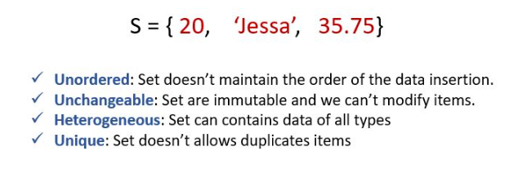

Set is an unordered collection of data items that are unique

Create set
set1={"apple", "orange", "cherry", "banana"}
print(set1)#{'apple', 'orange', 'banana', 'cherry'}

Empty set
myset=set()
print(myset)#set()
print(type(myset))#<class 'set'>
myset= {}
print(myset)# dict
print(type(myset)) # <class 'dict'>

Accessing element
Elements in the set can be done using for loop since sets are undordered
set1={"apple", "orange", "cherry", "banana"}
#print(set1[0]) #TypeError: 'set' object is not subscriptable
for i in set1:
print(i)

output:
apple
orange
banana
cherry

Add or Update set
set1={"apple", "orange", "cherry", "banana"}
#add() used to add single element
set1.add("kiwi") # single item
print(set1)#{'kiwi', 'apple', 'orange', 'banana', 'cherry'}

#update() used to add multiple element
set1.update({"kiwi", "dragon frt"}) # multiple item
print(set1)#{'kiwi', 'apple', 'orange', 'banana', 'cherry', 'dragon frt'}

Getting Length of set
set1={"apple", "orange", "cherry", "banana"}
print(len(set1))#4

Remove item
set1={"apple", "orange", "cherry", "banana"}
set1.pop()
print(set1)#{'apple', 'banana', 'orange'}
set1.remove("orange")
print(set1)#{'apple', 'banana'}
set1.discard("cherry")
print(set1)#{'apple', 'banana'}

- with non existing item
set1.remove("kiwi") #KeyError: 'kiwi'
print(set1)
set1.discard("kiwi")
print(set1) # no error# {'apple', 'banana', 'cherry', 'orange'}

set1.clear()
print(set1) # empty set# set()

Copying sets

set1={"apple", "orange", "cherry", "banana"}
print(f"set1: {set1} id : {id(set1)}")#set1: {'orange', 'banana', 'apple', 'cherry'} id : 2265804951776
set2=set1
print(f"set2: {set2} id : {id(set2)}")#set2: {'orange', 'banana', 'apple', 'cherry'} id : 2265804951776
set2.remove("apple")
print(f"set1: {set1} id : {id(set1)}")#set1: {'banana', 'cherry', 'orange'} id : 1706357084384
print(f"set2: {set2} id : {id(set2)}") # shallow copy
#set2: {'banana', 'cherry', 'orange'} id : 1706357084384
Note: in shallow copy, any element removed from set1 will remove element in set2 because both set1 and set2 refers same object
set3=set(set1) # deep copy
print(f"set3: {set3} id : {id(set3)}")#set3: {'cherry', 'banana', 'apple', 'orange'} id : 2220038408672
set3.remove("apple")
print(f"set1: {set1} id : {id(set1)}")#set1: {'cherry', 'banana', 'apple', 'orange'} id : 2220038413600
print(f"set3: {set3} id : {id(set3)}")#set3: {'cherry', 'banana', 'orange'} id : 2220038408672

Note: in deep copy, any element removed from set1 will not remove element in set3 because both set3 and set3 refers different object

set4=set1.copy() # deep copy
print(f"set4: {set4} id : {id(set4)}")#set4: {'banana', 'orange', 'apple', 'cherry'} id : 2205311158752
set4.remove("apple")
print(f"set1: {set1} id : {id(set1)}")#set1: {'banana', 'orange', 'apple', 'cherry'} id : 2205311163680
print(f"set4: {set4} id : {id(set4)}")#set4: {'banana', 'orange', 'cherry'} id : 2205311158752

combine sets

set1={"apple", "orange", "cherry", "banana"}
set2={10,20,30}
set4={10,20,40}
set3=set1.union(set2)
print(set3)#{'cherry', 'orange', 'banana', 10, 20, 'apple', 30}
# print(set2+set1) # TypeError: unsupported operand type(s) for +: 'set' and 'set'
print(set4.intersection(set2))#{10, 20}

with duplicate items

sets remove duplicate elements
s1={1,2,3,1,2,3}
print(s1)# {1, 2, 3}

Frozen sets
A frozenset is an immutable set. Frozen Set is thus an unordered collection of immutable unique items. create a frozenset using the frozenset() function, which takes a single iterable object as a parameter.

rainbow = ('violet', 'indigo', 'blue', 'green', 'yellow', 'orange', 'red')
# create a frozenset
f_set = frozenset(rainbow)
print(f_set)#{'green', 'yellow', 'indigo', 'red', 'blue', 'violet', 'orange'}

Dictionary
Dictionaries are ordered collections of unique values stored in (Key-Value) pairs.
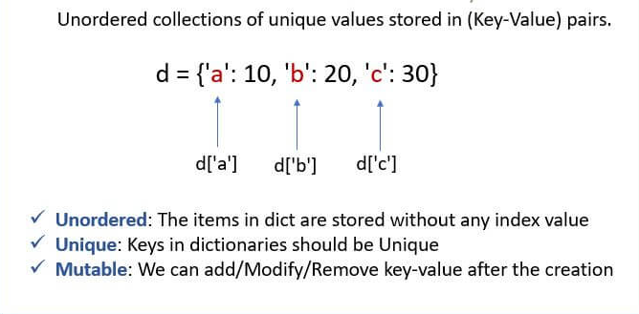

Create dictionary
mydict= {"brand":"Maruthi", "year": "2023", "model":1102}
print(mydict)#{'brand': 'Maruthi', 'year': '2023', 'model': 1102}
mydict= {101:"ram", 102:"sam", 103:"anne"}
print(mydict)#{101: 'ram', 102: 'sam', 103: 'anne'}
mydict=dict({"brand":"Maruthi", "year": "2023", "model":1102})
print(mydict)#{'brand': 'Maruthi', 'year': '2023', 'model': 1102}

with duplicate key
# with duplicate key
mydict={"brand":"Maruthi", "year": "2023", "model":1102, "brand":"hyndai", "brand":"Maruthi123", }
print(mydict)# {'brand': 'Maruthi123', 'year': '2023', 'model': 1102}

Accessing values
mydict= {"brand":"Maruthi", "year": "2023", "model":1102, "brand":"hyndai"}
# approach1
print(mydict["brand"])#hyndai
print(mydict["year"])#2023
print(mydict["model"])#1102
#approch2
print(mydict.get("brand"))#hyndai
print(mydict.get("year"))#2023

Change values

mydict= {"brand":"Maruthi", "year": "2023", "model":1102}

To change only one key value
print(mydict)#{'brand': 'Maruthi', 'year': '2023', 'model': 1102}
mydict["year"] = "2020"
print(mydict)#{'brand': 'Maruthi', 'year': '2020', 'model': 1102}

To change more than one key value

mydict.update({"year": "2022"})
print(mydict)#{'brand': 'Maruthi', 'year': '2022', 'model': 1102}
mydict.update({"brand": "hero", "model": 1103})
print(mydict)#{'brand': 'hero', 'year': '2022', 'model': 1103}

Reading Dictionary using for loop
mydict= {"brand":"Maruthi", "year": "2023", "model":1102}
#approach 1
for i in mydict:
print(i) # prints key

output:
brand
year
model
for i in mydict:
print(mydict[i])# prints value

output:
Maruthi
2023
1102

Using keys() and values() function
print(mydict.keys())#dict_keys(['brand', 'year', 'model'])
print(list(mydict.keys())[2])
print(mydict.values())
print(list(mydict.values())[1])#dict_values(['Maruthi', '2023', 1102])

for key in mydict.keys():
print(key)
output:
brand
year
model
for val in mydict.values():
print(val)

output:
Maruthi
2023
1102

Using items()
mydict= {"brand":"Maruthi", "year": "2023", "model":1102}
print(mydict.items())#dict_items([('brand', 'Maruthi'), ('year', '2023'), ('model', 1102)])
print(list(mydict.items())[1][0])
print(list(mydict.items())[1][1])
for key, val in mydict.items():
# print(key, val)
if "brand" == key:
print(val)
output:
Maruthi
2023
1102

Check existence of key or value
mydict= {"brand":"Maruthi", "year": "2023", "model":1102}
print("model" in mydict.keys())# true
print("20231wded" in mydict.values()) #false

Length of dictionary
mydict= {"brand":"Maruthi", "year": "2023", "model":1102}
print(len(mydict))#3
print(len(mydict.keys()))#3
print(len(mydict.values()))#3

Add new key and value
mydict= {"brand":"muruti", "year": "2023", "model":1102}
# approach 1
mydict["color"]="Black"
print(mydict)#{'brand': 'muruti', 'year': '2023', 'model': 1102, 'color': 'Black'}
# approach 2( to update more than one item)
mydict.update({'color': 'white', "seats": "6"})
print(mydict)#{'brand': 'muruti', 'year': '2023', 'model': 1102, 'color': 'white', 'seats': '6'}

Remove item from dictionary

mydict= {"brand":"muruti", "year": "2023", "model":1102}
# approach 1
print(mydict.pop("brand"))#muruti...(removes and return the value of the key removed)
print(mydict)#{'year': '2023', 'model': 1102}

# approach 2
mydict= {"brand":"muruti", "year": "2023", "model":1102}
print(mydict.popitem())#('model', 1102)..removes the item randomly and returns the item in tuple format
print(mydict)#{'brand': 'muruti', 'year': '2023'}

# approach 3
mydict= {"brand":"muruti", "year": "2023", "model":1102}
del mydict["brand"]
print(mydict)#{'year': '2023', 'model': 1102}
del mydict
print(mydict)#NameError: name 'mydict' is not defined. Did you mean: 'dict'?

# clear
mydict.clear()
print(mydict)#{}

Copy dictionary

mydict1= {"brand":"muruti", "year": "2023", "model":1102}
print(f" mydict1:{mydict1} id : {id(mydict1)}")#mydict1:{'brand': 'muruti', 'year': '2023', 'model': 1102} id : 1615163519360
mydict2=mydict1 # swallow copy
mydict2.pop("brand")
print(f" mydict1:{mydict1} id : {id(mydict1)}")#mydict1:{'year': '2023', 'model': 1102} id : 1543279702400
print(f" mydict2:{mydict2} id : {id(mydict2)}")#mydict2:{'year': '2023', 'model': 1102} id : 1543279702400
Note: in swallow copy, any element removed from mydict1 will remove element in mydict2 because both mydict1 and mydict2 refers same object

mydict1= {"brand":"muruti", "year": "2023", "model":1102}
mydict3=mydict1.copy() # deep copy
print(f" mydict1:{mydict1} id : {id(mydict1)}")#mydict1:{'brand': 'muruti', 'year': '2023', 'model': 1102} id : 2641343967616
print(f" mydict3:{mydict3} id : {id(mydict3)}")#mydict3:{'brand': 'muruti', 'year': '2023', 'model': 1102} id : 2641343968256

Note: in deep copy, any element removed from mydict1 will not remove element in mydict3 because both mydict1 and mydict3 refers different object

mydict4=dict(mydict1) # deep copy
print(f" mydict1:{mydict1} id : {id(mydict1)}")#mydict1:{'brand': 'muruti', 'year': '2023', 'model': 1102} id : 2722310287744
print(f" mydict4:{mydict4} id : {id(mydict4)}")#mydict4:{'brand': 'muruti', 'year': '2023', 'model': 1102} id : 2722310815104

Combine two dictionary
mydict1= {"brand":"muruti", "year": "2023", "model":1102}
mydict2= {101:"ram", 102:"sam", 103:"anne"}
#print(mydict1+mydict2) # typeerror
mydict1.update(mydict2)
print(mydict1)#{'brand': 'muruti', 'year': '2023', 'model': 1102, 101: 'ram', 102: 'sam', 103: 'anne'}

Note : we can use update function for combine, add and update the dictonary

List | Tuple | Set | Dictionary
A list is a non-homogeneous data structure that stores the elements in columns of a single row or multiple rows. | A Tuple is also a non-homogeneous data structure that stores elements in columns of a single row or multiple rows. | The set data structure is also a non-homogeneous data structure but stores the elements in a single row. | A dictionary is also a non-homogeneous data structure that stores key-value pairs.
The list can be represented by  [ ] | Tuple can be represented by  ( ) | The set can be represented by  { } | The dictionary can be represented by  { }
The list allows duplicate elements | Tuple allows duplicate elements | The Set will not allow duplicate elements | The dictionary doesn’t allow duplicate keys.
The list can use nested among all | Tuple can use nested among all | The set can use nested among all | The dictionary can use nested among all
Example: [1, 2, 3, 4, 5] | Example: (1, 2, 3, 4, 5) | Example: {1, 2, 3, 4, 5} | Example: {1: “a”, 2: “b”, 3: “c”, 4: “d”, 5: “e”}
A list can be created using the list() function | Tuple can be created using the tuple() function. | A setA dictionary can be created using the set() function | A dictionary can be created using the dict() function.
A list is mutable i.e we can make any changes in the list. | A tuple is immutable i.e we can not make any changes in the tuple. | A set is mutable i.e we can make any changes in the set, ut elements are not duplicated. | A dictionary is mutable, ut Keys are not duplicated.
List is ordered | Tuple is ordered | Set is unordered | Dictionary is ordered (Python 3.7 and above)
Creating an empty list  l=[] | Creating an empty Tuple  t=() | Creating a set  a=set()  b=set(a) | Creating an empty dictionary  d={}

Exercise

https://pynative.com/python-list-exercise-with-solutions/
https://pynative.com/python-tuple-exercise-with-solutions/
https://pynative.com/python-dictionary-exercise-with-solutions/
https://pynative.com/python-set-exercise-with-solutions/

